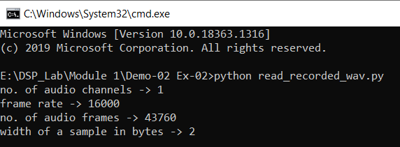

Frame rate = sampling rate = 16 kHz

what values are returned by getsampwidth()? -> 02 (bytes)-> 16bit